Extraction Framework overview
Document version 1.0, 11/27/99, Thierry Sourbier

Purpose

This document provides an high level overview of the Extraction Framework (EF). It is intended to:
- Developers who have to create new extractors for the framework.
- End users of the framework.
- Anybody interested in the EF.

Presentation
The Extraction Framework describes the general architecture and APIs in which various components are plugged to form the Extraction module. Components include:
- Format specific Parser/extractor
- Rule engine, to allow easy customization of the various parser
- Linguistic segmentation, to break text into sentences.
- Etc…
Before examining how the various pieces interact with one another lets have a look at the final module and how it interacts with the rest of the system.

Extraction module

Role
The role of the Extraction module is to separate the material to be translated and/or localized (e.g. as font name, path name, etc.) from the material that will be unaffected by localization. The input of the framework can be anything such as a file, a byte stream, an URL. The output is a list of segment, each segment contains some material to translate or localize, and a skeleton which contains all the material not to be translated. The Merger framework (MF) will have the reverse effect, and will create from the segment list and skeleton a file, a byte stream or anything else useful to recreate the localized input.
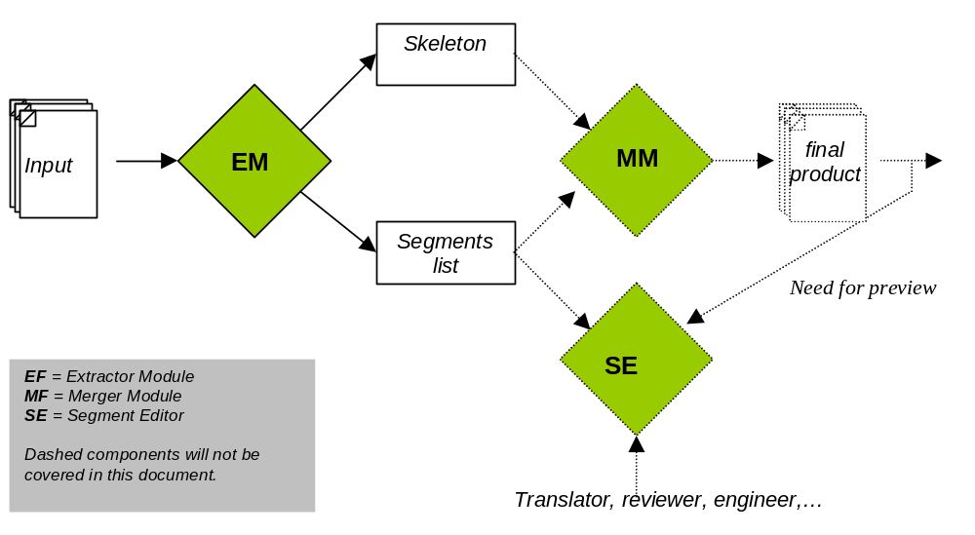

Skeleton format
There's no skeleton format per se. The skeleton contains all data that do not need to be changed during the l10n step in the order they were received. All information that needs to be translated (text displayed) or changed (path name, font name, etc...) has been replaced by a segment placeholder.
The segment placeholder can be customized for each format, and should be unique enough so that there is no need to escape the rest of the data. Currently the HTML or JavaScript extractor only pull out the text to translate. The extraction of localizable attributes is next on the list. We roughly have:
For each piece of data
if not translatable or localizable
write to skeleton
else
write placeholder in skeleton
add piece of data to list of things to translate or localize
end if.
end for.
Let's look at a very simple example with a simple HTML file:

<HTML>
<HEAD>
<TITLE>Hello world page</TITLE>
</HEAD>
<BODY>
Hello <B> world </B>!!
</BODY>
</HTML>

If the the placeholder is <!--{seg ID}-->. The place holder will look like:

<HTML>
<HEAD>
<TITLE><!--{Seg 1}--></TITLE>
</HEAD>
<BODY>
<!--{Seg 2}-->
</BODY>
</HTML>

Note that the term piece of data used in the pseudo code is volontary very vague. The EF needs to provide segment that are big enough to provide the translator with some context for him/her do a good translation. In the previous example, it would have make much sense to extract "Hello" and "world" as separate segment, leaving the <b> tag in the skeleton.
That brings the point that some of the document formatting/structure is considered embeddable (can be included in segment) while the rest of the formatting has to go in the skeleton thus forces the creation of a new segment. The skeleton is used to protect the structure of the document. In our previous example no matter how first segment is translated it will always be a title. While in the second we can imagine that for far east language the bolding effect is removed. Note that not all embeddable tags can be freely added, removed, moved or otherwise modified. It will be up to the segment editor to protect the one that cannot be modified.

Segment format
Each segment is composed of an ID, a Type, a String and some other more technical information. The ID is used to link the segment to the placeholder. The type indicates the original format of the segment. The string contains the text to translate as well as possibly some embeddable tags that may need localization. As seen before the segment editor needs to offer some protection for various tags. This task can be very difficult to achieve due to the number of formats we are dealing with (from custom XML formats to RTF eventually). This is why we decided to wrap all the tag using TMX format. TMX is an XML based format designed as a standard for Translation Memory eXchange, which offers us some additional advantages. The full description of this format can be found at http://www.lisa.org/tmx/.

<HTML>
…
<BODY>
Hello <B>world</B>!!.
</BODY>
</HTML>

The skeleton will look like:

<HTML>
…
<BODY>
<!--{Seg 1}-->
</BODY>
</HTML>

And the segment list like:

ID Type String
1 HTML Hello <bpt type="bold" i=1>&lt;B&gt;</bpt>world<ept i=1>&lt;/B&gt;</ept>!!.

In the previous example the opening tag is wrapped between <bpt> tags and the closing tag is wrapped with <ept> ones. This looks intimidating but will provide to the segment editor the necessary information to make things as easy as possible for the translator and avoid mistakes. It will allow for example to offer bsic WYSIWYG capabilities to the segment editor.
As you were able to see also the bpt tag add a type="bold" attribute. The TMX specifications includes recommendation for the type attribute of the bpt tag for very common destop publishing tags. A "bold" tag looks very different in RTF, MIF, INTERLEAF, HTML but means the same in all cases. It is the responsibility of the EF to provide the mapping between "tag" and attributes according to the recommendation of the OSCAR group.
TMX may be a little heavy for such a thing, we could directly replace any *bold* tag with a generic bold tag say <bold>. Because we are doing TM, it was decided to go the TMX route so we can easily import/export our TMs and all our segments are self-contained, giving possibly more control for experience users.

Sentence breaking
In order to provide a finer grain TM that ultimately will provide greater leveragability of new or updated material, all the segments are actually broken further into sentences. For example

<HTML>
…
<BODY>
All humans are mortal. Socrates is a human, thus Socrates is a mortal.
</BODY>
</HTML>

The skeleton will look like:

<HTML>
…
<BODY>
<!--{Seg 1}-->
</BODY>
</HTML>

And the segment list like:

ID Type String
1 HTML All humans are mortal.
1 HTML Socrates is a human, thus Socrates is a mortal.

It is no error that there is only one segment in the skeleton. Indeed the format of the document doesn’t dictate any break within the segment, it is our choice to do so by analyzing the text and breaking it at sentence boundaries. You'll notice that both segment refer to the same segment ID, which mean that to reconstruct the document later they will need to be concatenated before the merging in the order in which they appear in the list.
There is an added benefice to that, for language such as Japanese, good translators often needs to reorder the various sentences to provide a better translation. With our model, any segments that has the same ID can be freely merged (all segments can be split). That offers greater flexibility for the translation offering an easy way to distinguish between breaks caused by the format and "soft break" breaks caused by the sentence breaker.

Extraction Framework

Blue print
Will describe how the various module interact together

Parsers/extractors
Will describe the high level API and role of the parser. What is expected from each parser-extractor…

Rules engine
Will describe the high level API and role of the rule engine. Discuss the basic rule format and reason being of the module

Linguistic Segmentation
Will describe the high level API and role of the rule engine.

TMX Cleaner

What else to include?

